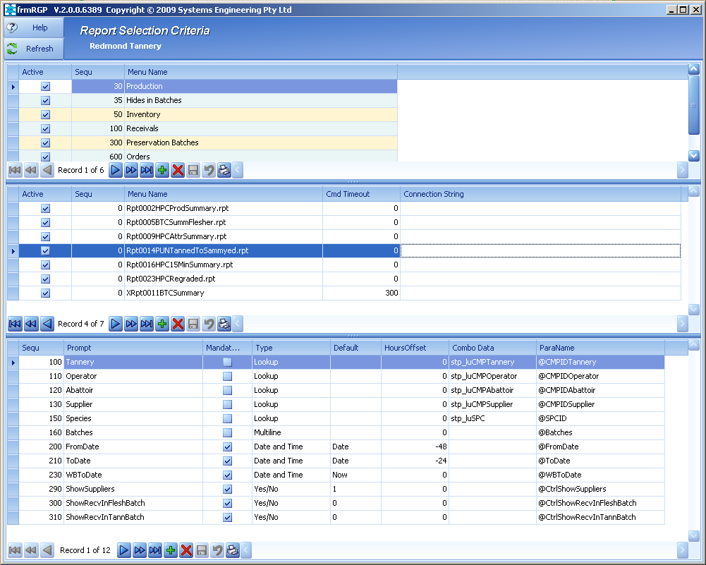
Three tables are used to configure all report selection presented to the user. When a new report is created it simply is added to this set of control tables.
Report Groups
Reports within Groups
Menu Name is also the report name - .rpt extension are Crystal Reports and no extension are DevExpress Reports.
Connection String never used but there if needed.
Report Data Selection Criteria
Combo Data contains the procs to use to populate the lookups.
Para Names and parameters the reports stored procedure is expecting
@Ctrl.. are not data selection parameters but they are embedded in the Select statement for the report so they are available at runtime for the report to use to take certain actions, e.g. @CtrlShowSupplies = False then the report will not show supplier details.

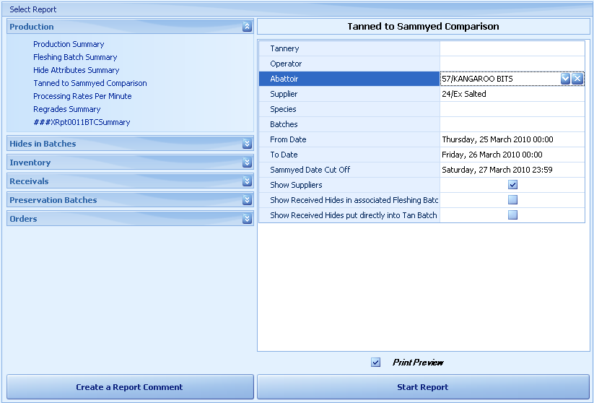

The above control tables are brought together in this report selection form.
The left hand side presents the data from: Report Groups and Reports within Groups.
The right hand side is redrawn and controls added / removed as needed to present the data selection criteria as determined by Report Data Selection Criteria.
Left hand side is a DevExpress NavBar control and the right hand side is DevExpress VGrid control.
Once Start Report is clicked the report is run using the following process (DX reports example):
Instantiate the report.:
Dim asm1 As System.Reflection.Assembly = System.Reflection.Assembly.GetEntryAssembly
For Each type As Type In asm1.GetTypes()
If type.IsSubclassOf(GetType(DevExpress.XtraReports.UI.XtraReport)) Then
If (type.Name = ReportName) Then
myReport = DirectCast(Activator.CreateInstance(type), XtraReport)
Exit For
End If
End If
Next type
Note: ReportName is the value in “Menu Name” in first screen.

Instantiate the BO for the report. All our reports and associated BO’s are in the same project.
ReportBOName = String.Format("bo{0}", myReport.DataMember.Substring(4, myReport.DataMember.Length - 4))

Dim asm As System.Reflection.Assembly = System.Reflection.Assembly.GetEntryAssembly
For Each type As Type In asm.GetTypes()
If type.IsSubclassOf(GetType(MicroFour.StrataFrame.Business.BusinessLayer)) Then
If (type.Name = ReportBOName) Then
bo = CType(Activator.CreateInstance(type), MicroFour.StrataFrame.Business.BusinessLayer)
Exit For
End If
End If
Next type

The VGrid control is parsed and a System.Data.SqlClient.SqlParameter collection is created that contains all the parameter values required by the report’s stored procedure. Only parameters that have values are created. The report’s proc actually has sensible default values for most parameters.

A System.Data.SqlClient.SqlCommand object is created and given the above SqlParamenters. The report’s BO is populated using SqlCommand and the BO’s FillDataTable method.

We then iterate through all the labels on the report and localise their values. While doing this we identify sub reports and create and populate their BO’s in the same manner as we did for the main report. The sub reports are also instantiated and their label values localised. This step also sets up all standard header / footer values for the report.

Finally we assign the bo.CurrentDataTable to the main report (we have already done this for any sub reports in the above step) and show the report to the user.

