TmHeadCFD form is the parent form based on SF maintenance class. It manages the parent BO called TemHeadBO (“template header”).

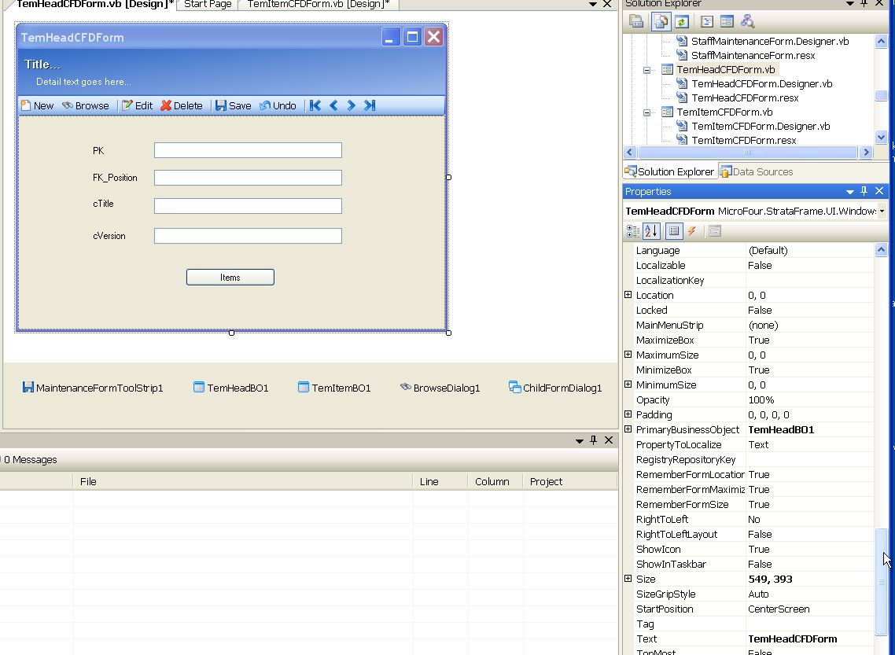

TemItemBO1 has TemHeadBO1 as its ParentBusinessObject:

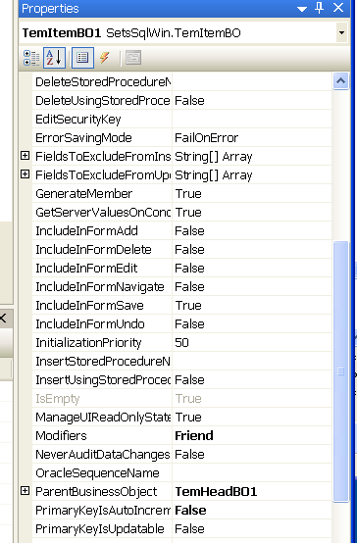

The child form dialog settings on the parent form. The TemItemCFDForm is called to manage template items associated with a given template header record in the parent form.

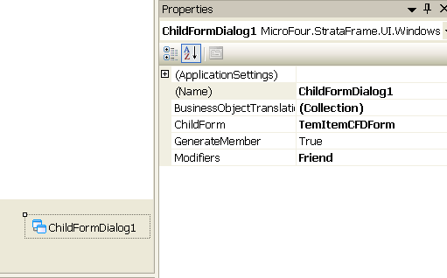

Translation settings to child form TemItemCFDForm.

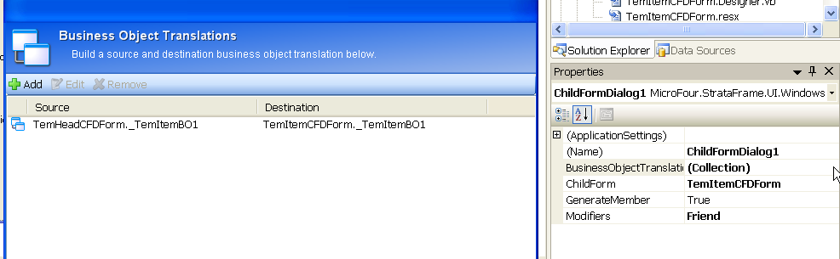
Child Form. When called as a child form, it is correctly filled with only those records whose FK_TemHead matches the PK of the parent. The “FillAll” button is the alternative way of filling TemItemBO1 when called directly as a free standing form. When called as a child form, the browse dialog does not position the records. When called directly (and filled using the “FillAll”) button, the browse dialoge does work correctly.

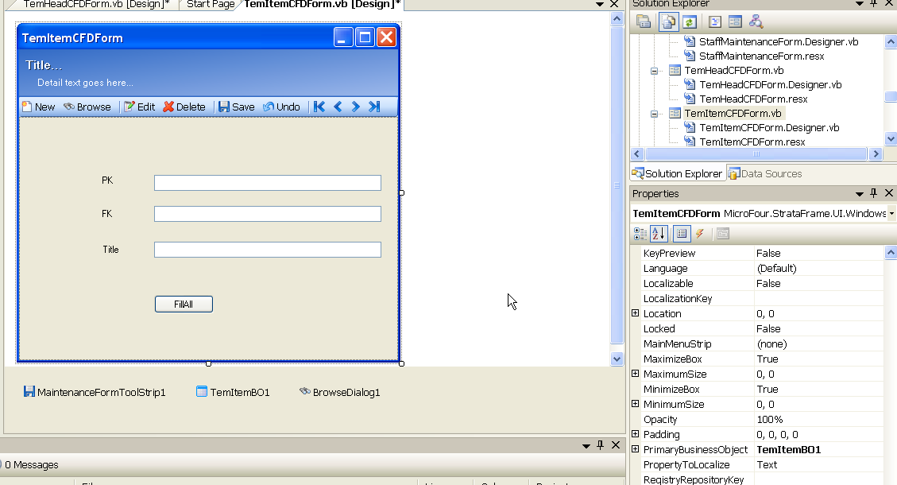

Browse dialog on child form. Only essential setting were set for the BO and browse results.

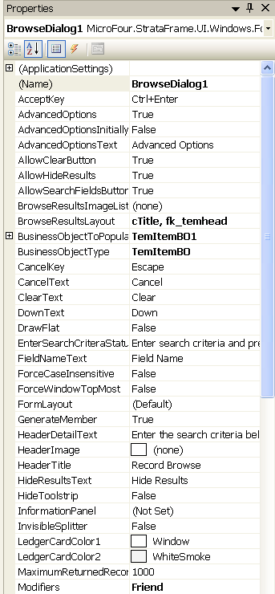
Browse Dialog properties on Child form continued. Only essential settings were made for search fields.

